WEEK 06
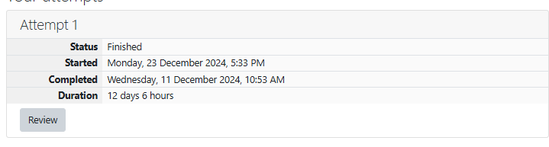
Problem Statement:
Given an array A of sorted integers and another non negative integer k, find if there
exists 2 indices i and j such that A[i] - A[j] = k, i != j.
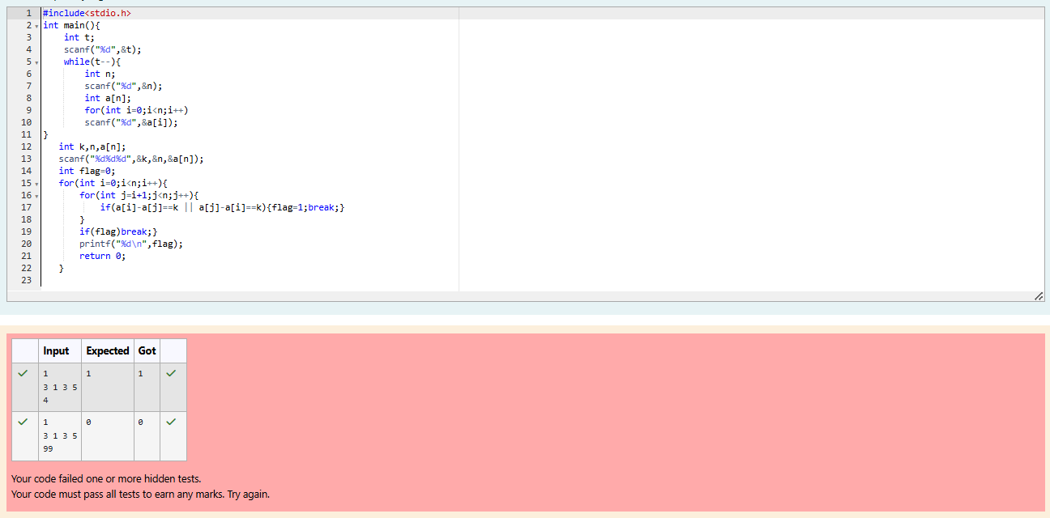
GE23131 - Programming Using C
81Department of Computer Science and Engineering, Rajalakshmi Engineering College
Ex. No. : Date :
Chocolates
Problem Statement:
Sam loves chocolates and starts buying them on the 1st day of the year. Each day of the
year, x, is numbered from 1 to Y. On days when x is odd, Sam will buy x chocolates; on
days when x is even, Sam will not purchase any chocolates.
Complete the code in the editor so that for each day Ni (where 1 ≤ x ≤ N ≤ Y) in array
arr, the number of chocolates Sam purchased (during days 1 through N) is printed on a
new line. This is a function-only challenge, so input is handled for you by the locked stub
code in the editor.
Input Format
The program takes an array of integers as a parameter.
The locked code in the editor handles reading the following input from stdin, assembling
it into an array of integers (arr), and calling calculate(arr).
The first line of input contains an integer, T (the number of test cases). Each line i of
the T subsequent lines describes the ith test case as an integer, Ni (the number of days
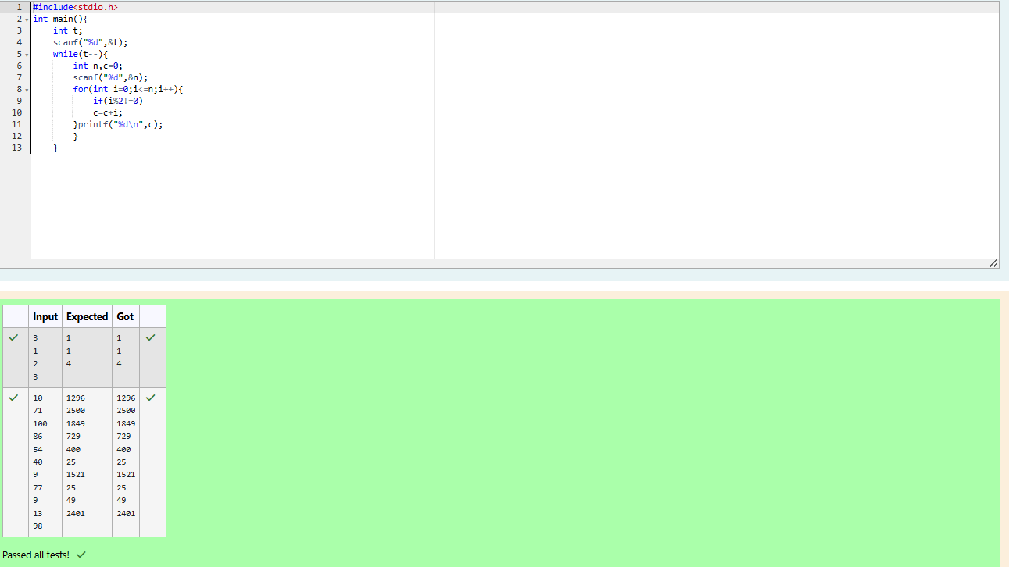
Problem Statement:
The number of goals achieved by two football teams in matches in a league is given in the
form of two lists. Consider:
• Football team A, has played three matches, and has scored { 1 , 2 , 3 } goals in each match
respectively.
• Football team B, has played two matches, and has scored { 2, 4 } goals in each match
respectively.

• Your task is to compute, for each match of team B, the total number of matches of team A,
• where team A has scored less than or equal to the number of goals scored by team B in
that match.
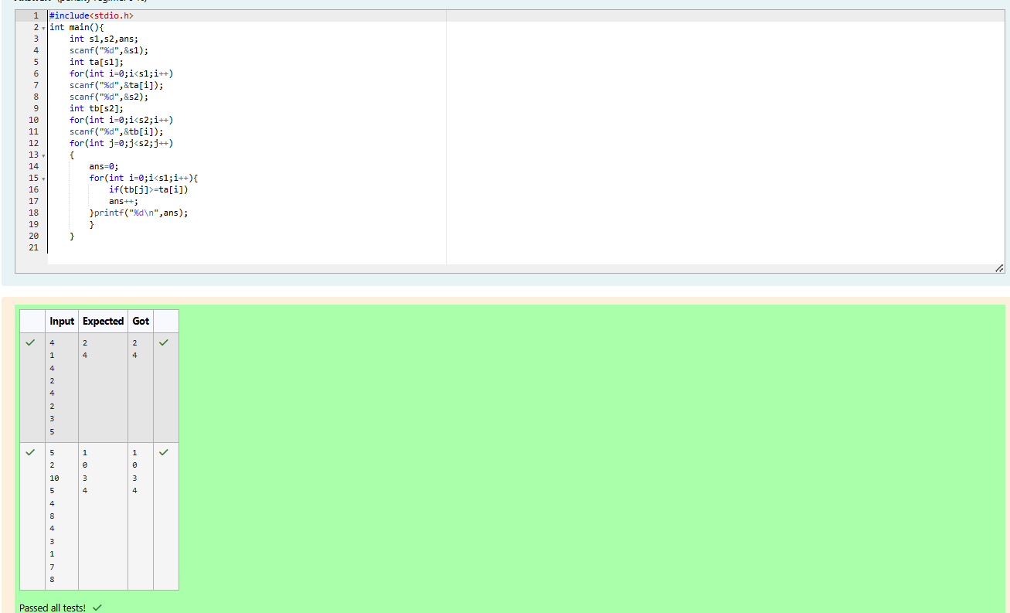
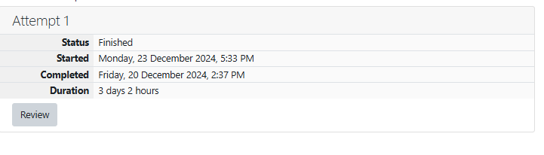
Problem Statement:
Sunny and Johnny like to pool their money and go to the ice cream parlor. Johnny
never buys the same flavor that Sunny does. The only other rule they have is that they
spend all of their money.
Given a list of prices for the flavors of ice cream, select the two that will cost all of
the money they have.
For example, they have m = 6 to spend and there are flavors costing cost = [1, 2, 3,
4, 5, 6]. The two flavors costing 1 and 5 meet the criteria. Using 1-based indexing, they are
at indices 1 and 4.
Complete the code in the editor below. It should return an array containing the
indices of the prices of the two flavors they buy, sorted ascending.
It has the following:
• m: an integer denoting the amount of money they have to spend
• cost: an integer array denoting the cost of each flavor of ice cream
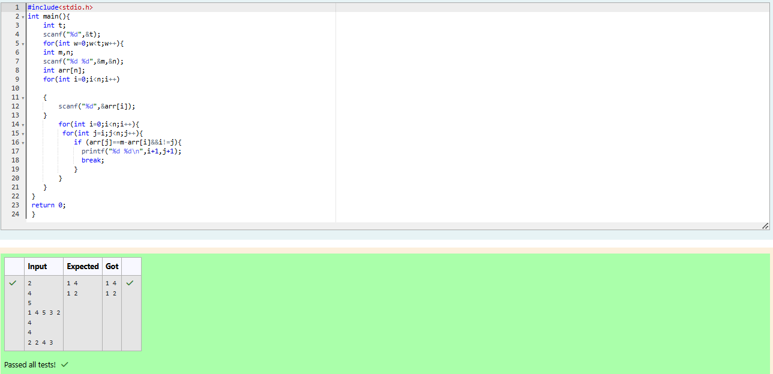
Problem Statement:
Numeros the Artist had two lists that were permutations of one another. He was very proud.
Unfortunately, while transporting them from one exhibition to another, some numbers
were lost out of the first list. Can you find the missing numbers?
As an example, the array with some numbers missing, arr = [7, 2, 5, 3, 5, 3]. The original
array of numbers brr = [7, 2, 5, 4, 6, 3, 5, 3]. The numbers missing are [4, 6].
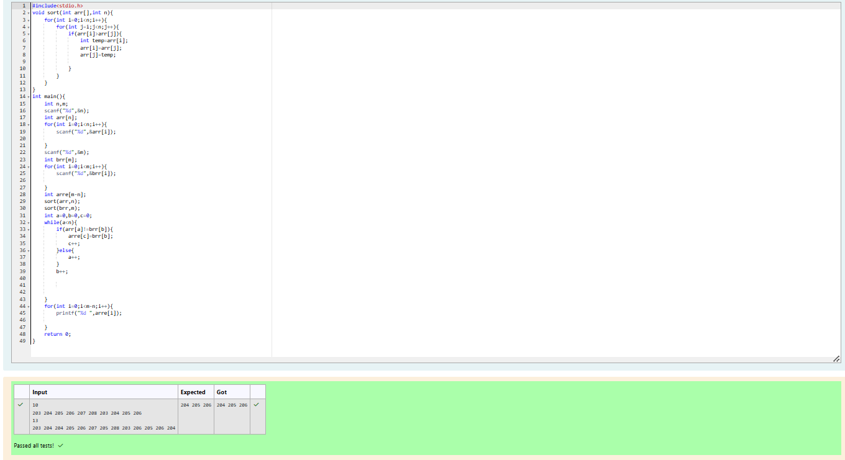
Problem Statement:
Watson gives Sherlock an array of integers. His challenge is to find an element of
the array such that the sum of all elements to the left is equal to the sum of all elements to
the right. For instance, given the array arr = [5, 6, 8, 11], 8 is between two subarrays that
sum to 11. If your starting array is [1], that element satisfies the rule as left and right sum
to 0. You will be given arrays of integers and must determine whether there is an element
that meets the criterion.
Complete the code in the editor below. It should return a string, either YES if there
is an element meeting the criterion or NO otherwise. It has the following: arr: an array of
integers
